AIR UNIVERSITY  ISLAMABAD CAMPUS • ACADEMIC SUBMISSION | AU

ACADEMIC ASSIGNMENT
Assignment 1:
NO. 01
Full Stack Web Development
Lab 1 Task
SUBMISSION DETAILS
COURSE CODE | [CS – 000]
SUBMITTED TO | Miss Fizza
SUBMITTED BY | Muhammad Zakria
REGISTRATION NO. | 241856
PROGRAM | BS Computer Science
SEMESTER / SECTION | 5th Semester • Section [C]
SUBMISSION DATE | 9/11/2026
PREPARED FOR ACADEMIC SUBMISSION
Air University • Islamabad, Pakistan | BSCS • SEM 05

Main Task:
Personal Portfolio:
Main purpose is to make a personal portfolio using concepts studied in Lab like HTML , Css and Bootstrap.
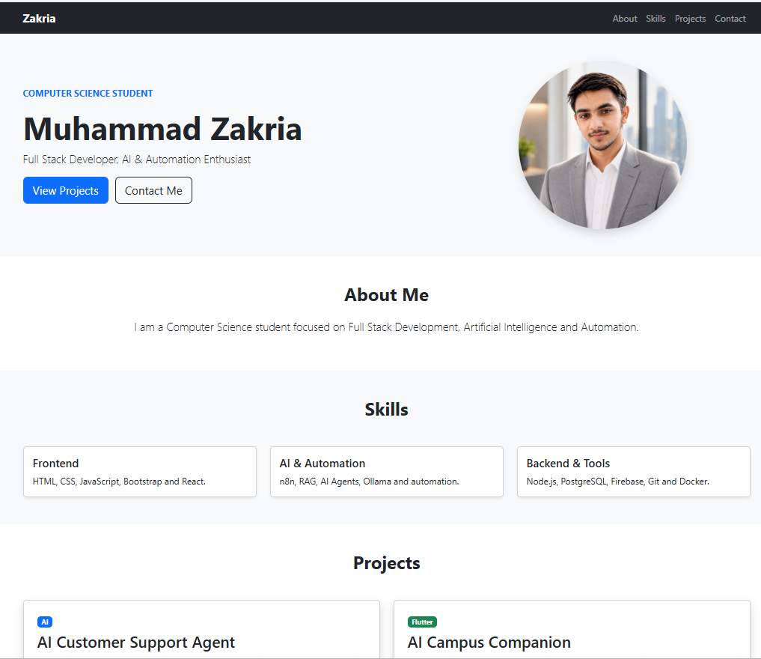
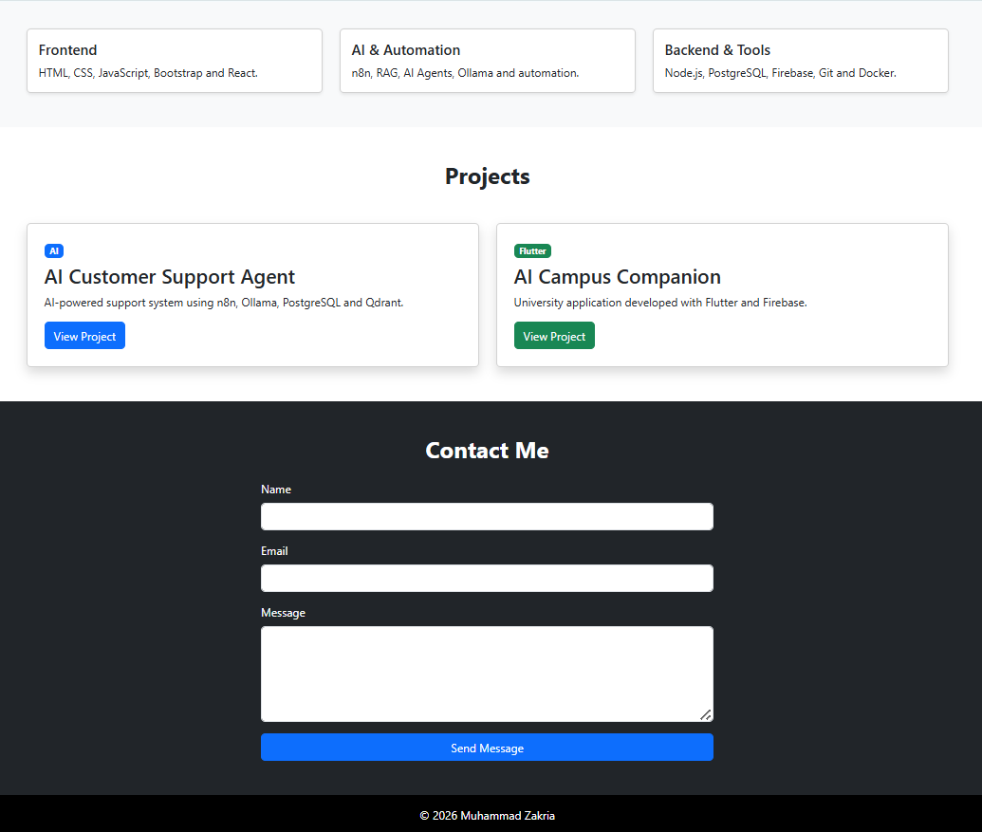
Task 1:
HTML:
Started todays Lab with basic HTML Tags.
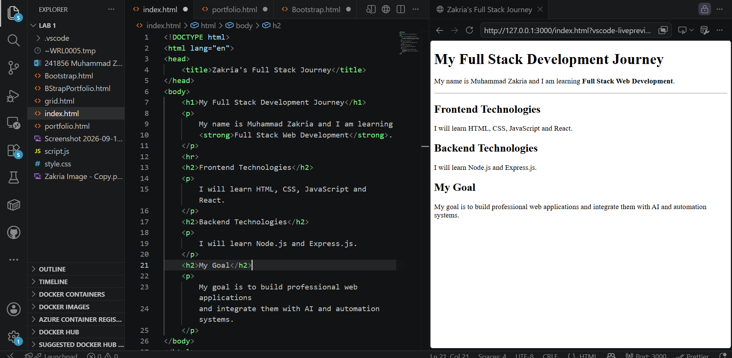

Task 2:
HTML CSS and Bootstrap
Then had done css and applied bootstrap on it.
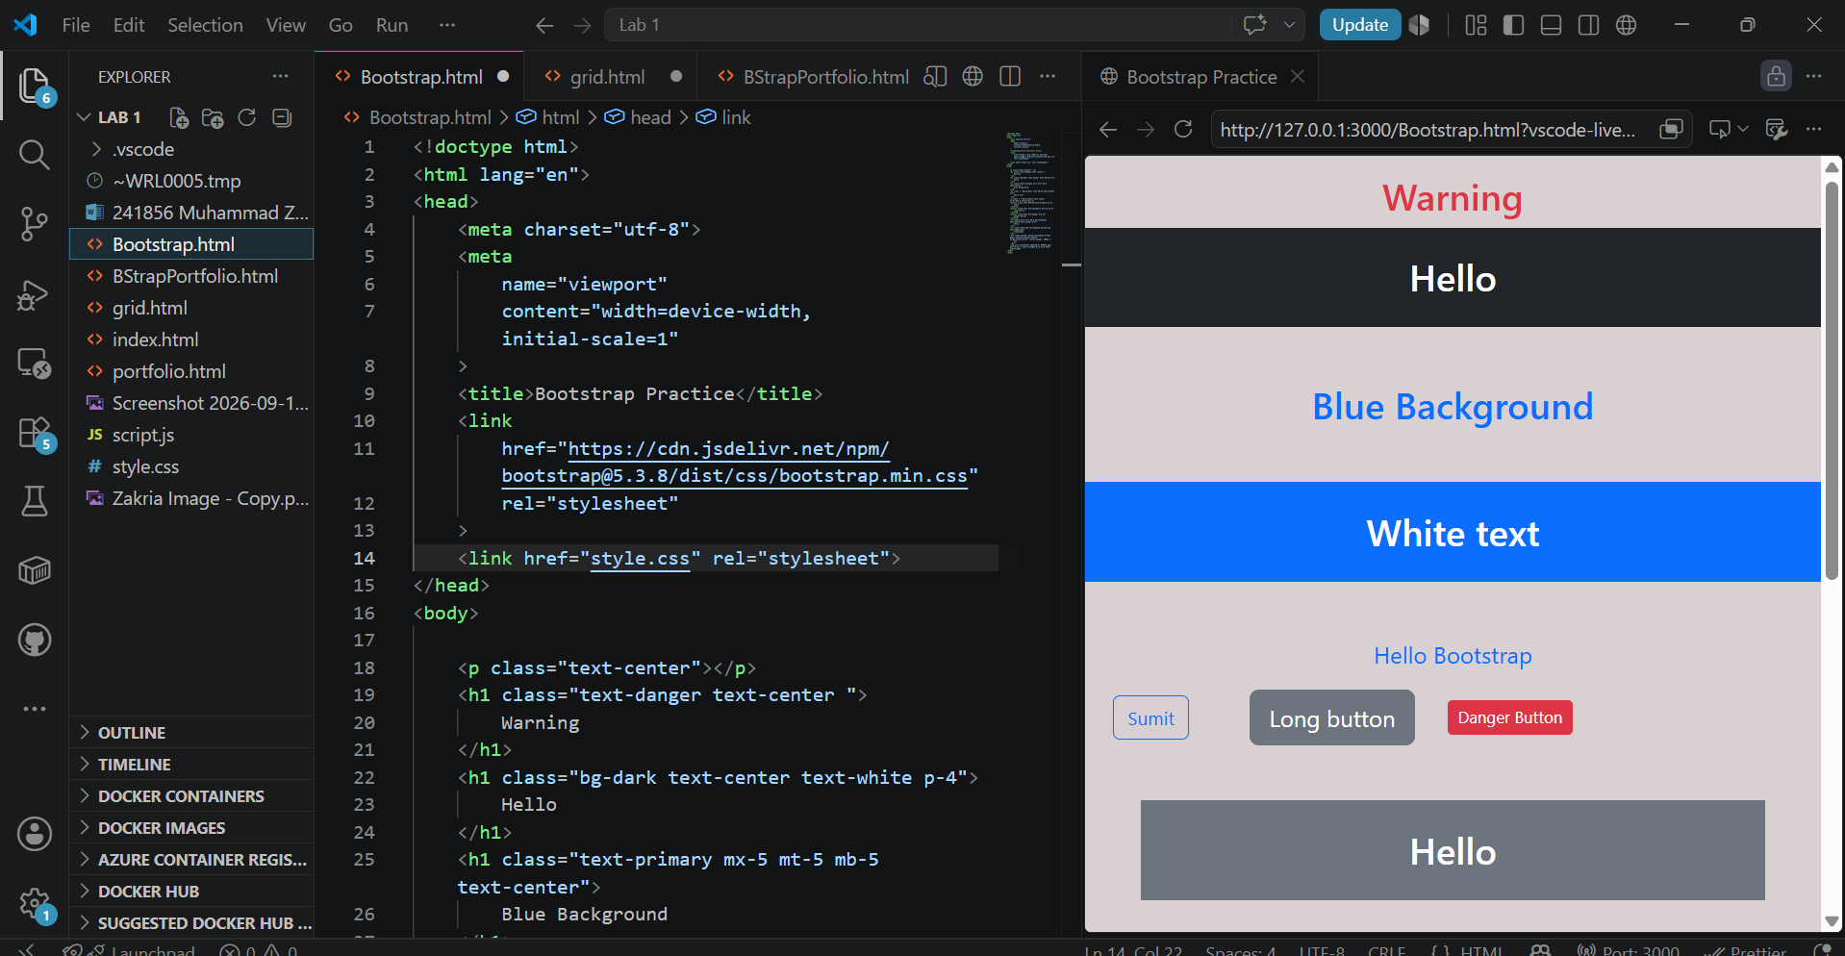
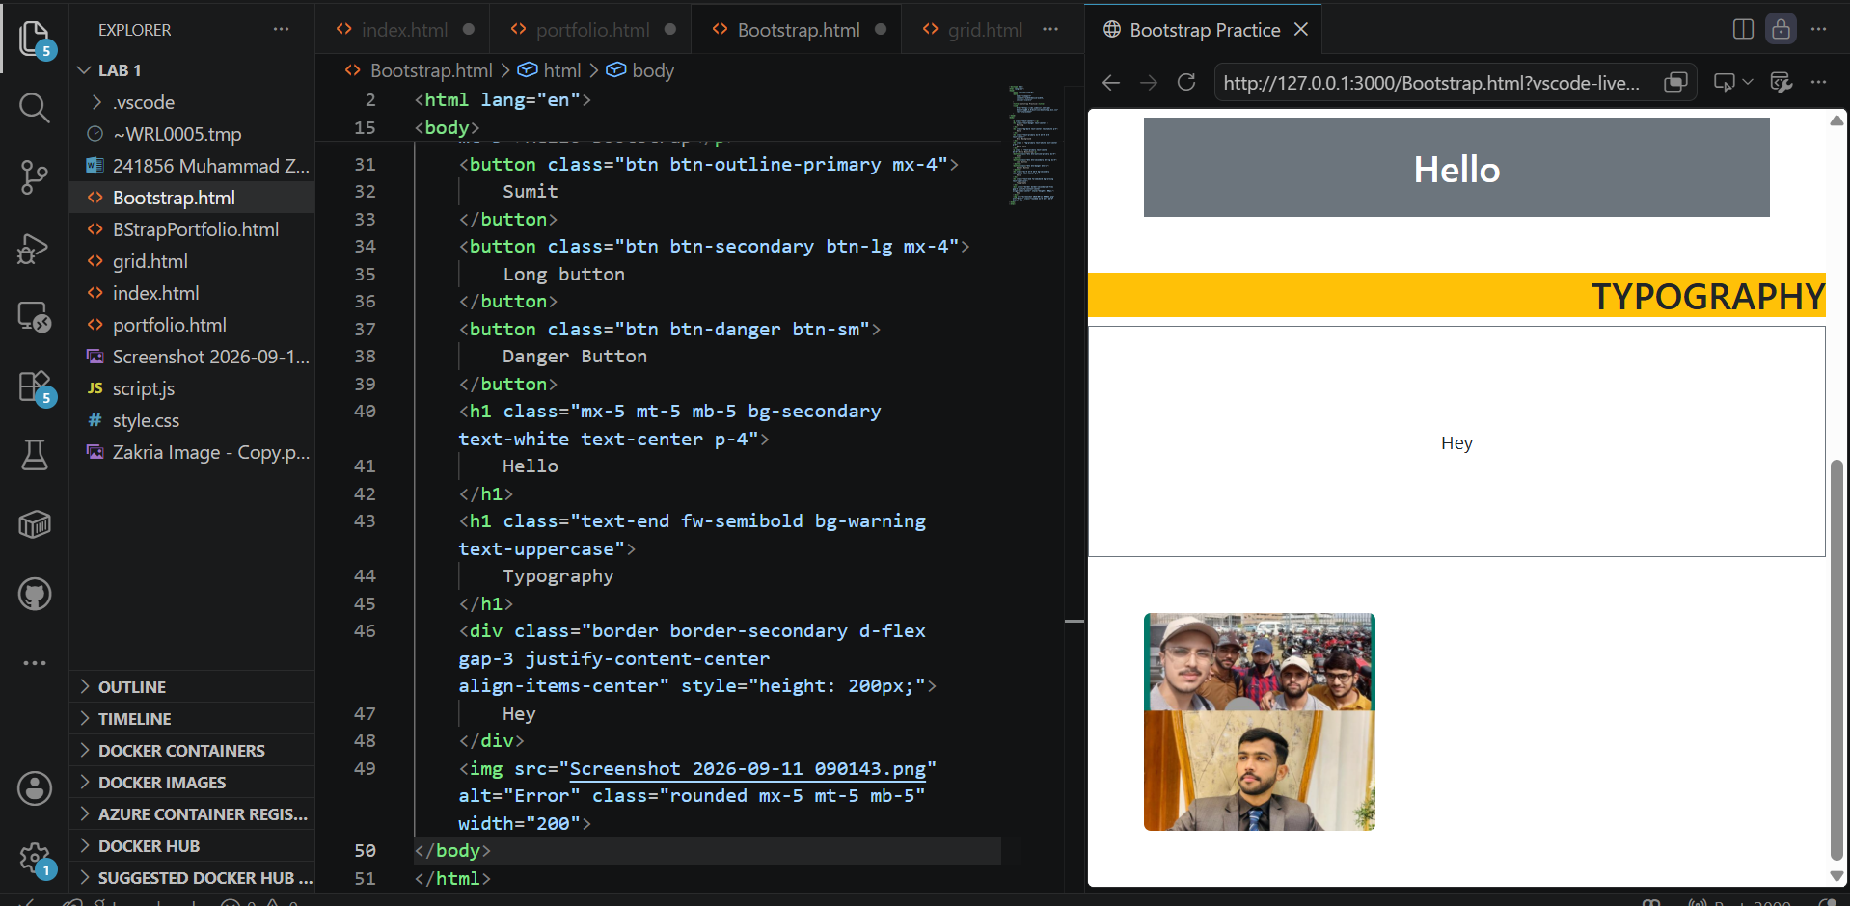
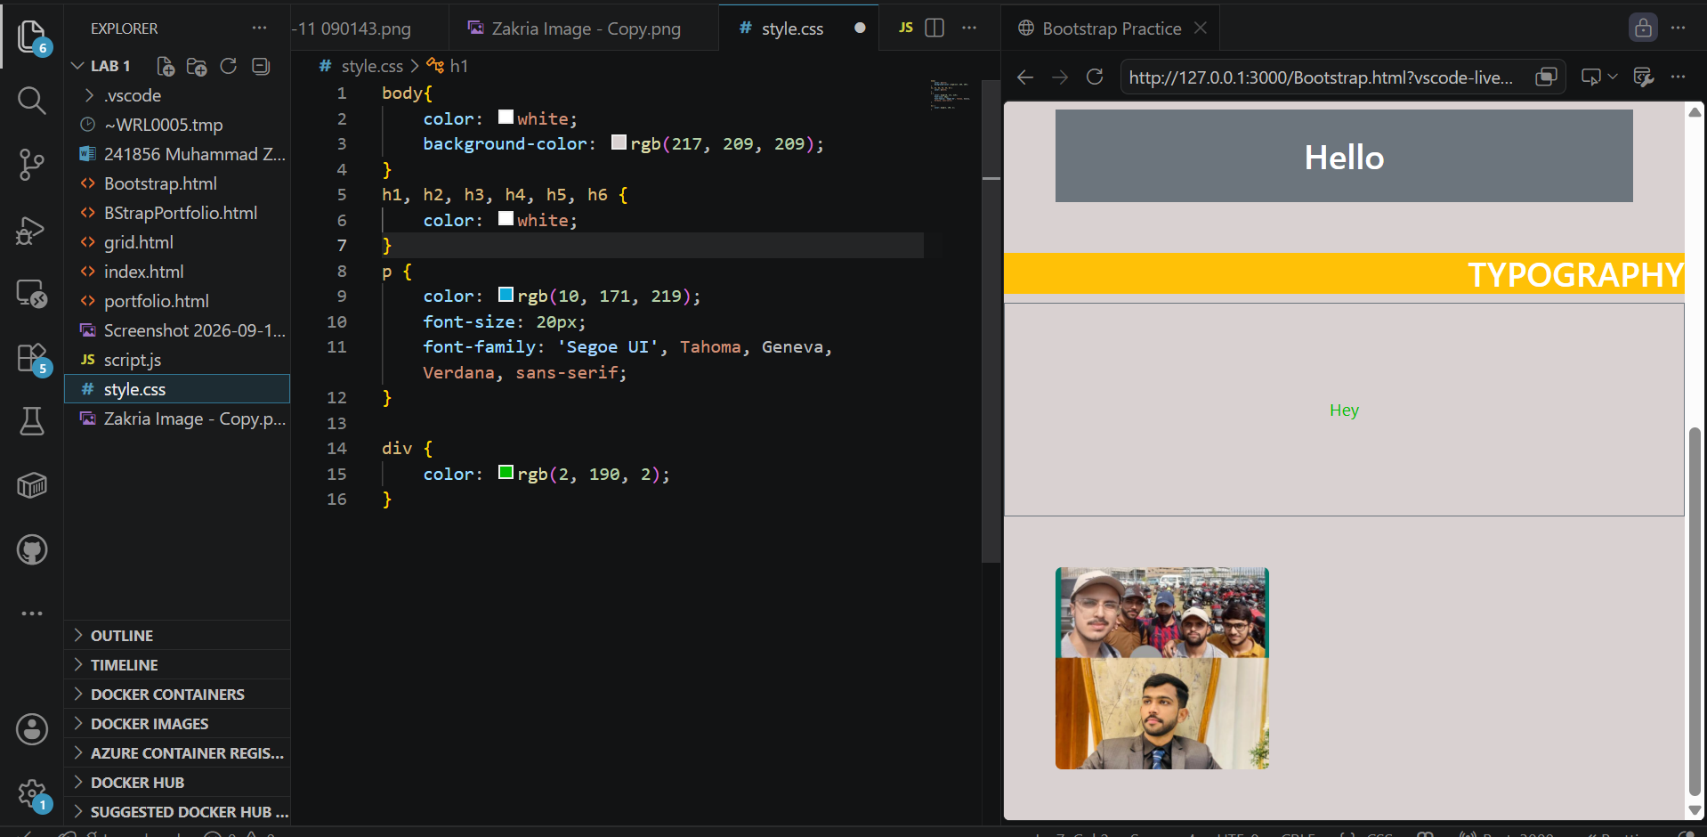

Task 3:
HTML Bootstrap:
Main work is to understand the concepts of container and columns like columns are 12 and divided according our self.
Here we divided for laptop mobile tablet and large screens.
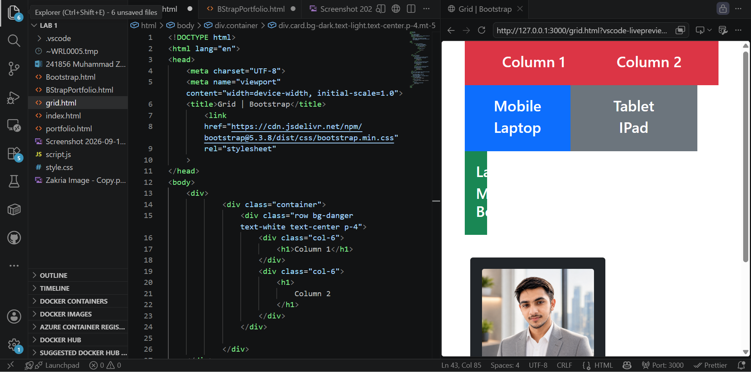
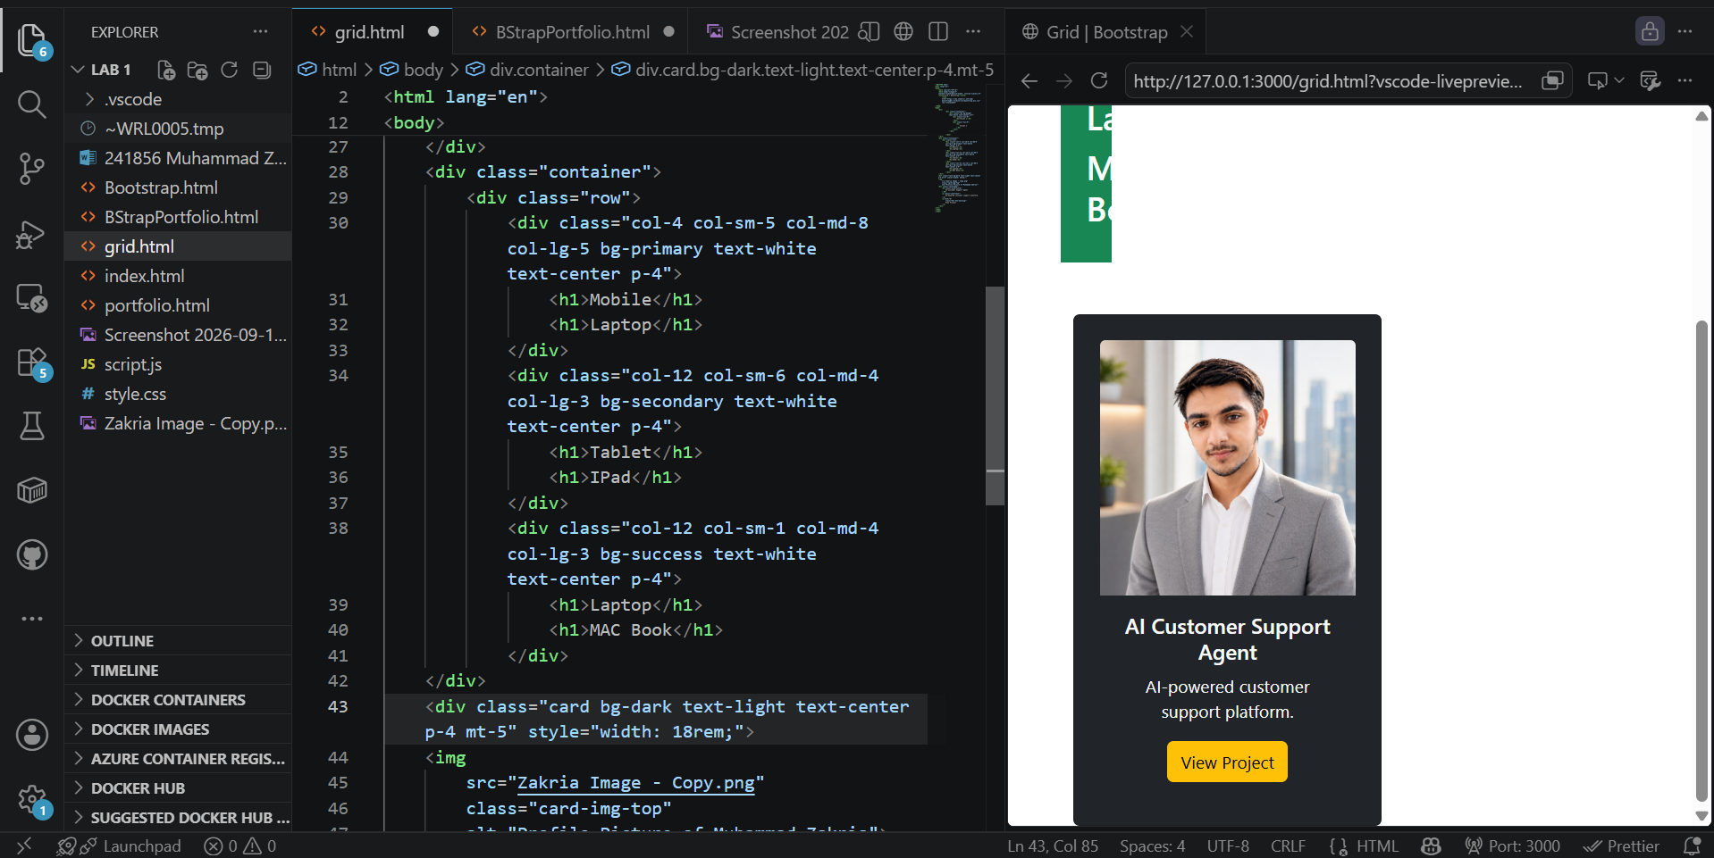
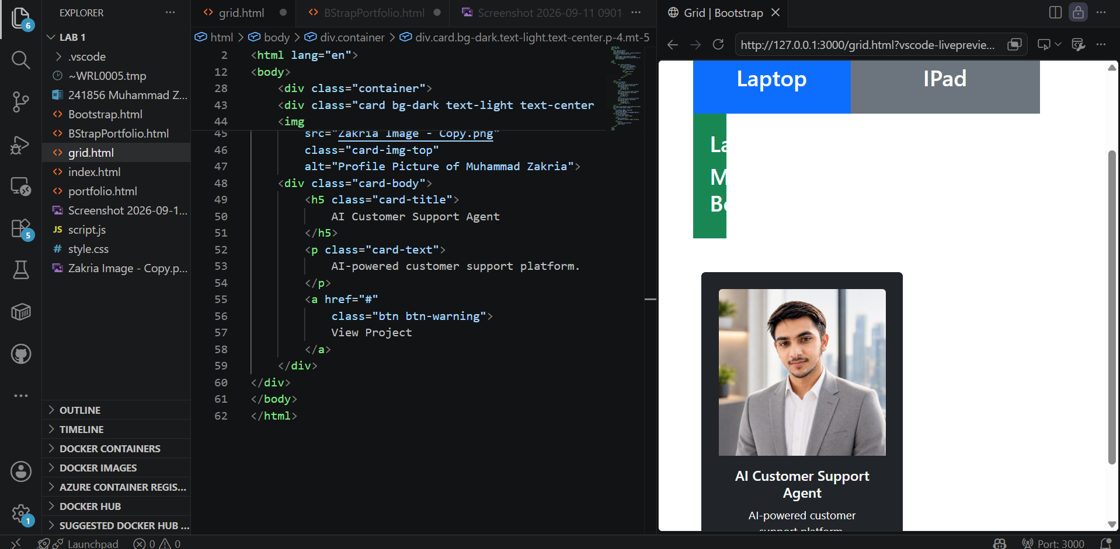

Task 4:
Personal Portfolio :
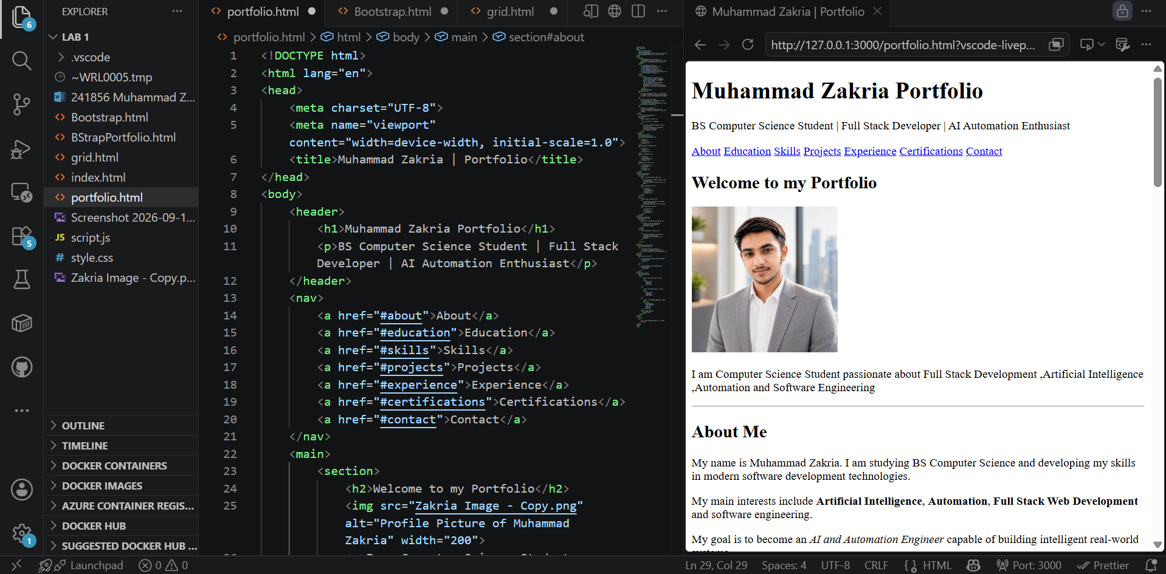
Main work here is to apply the concepts studied of Html .
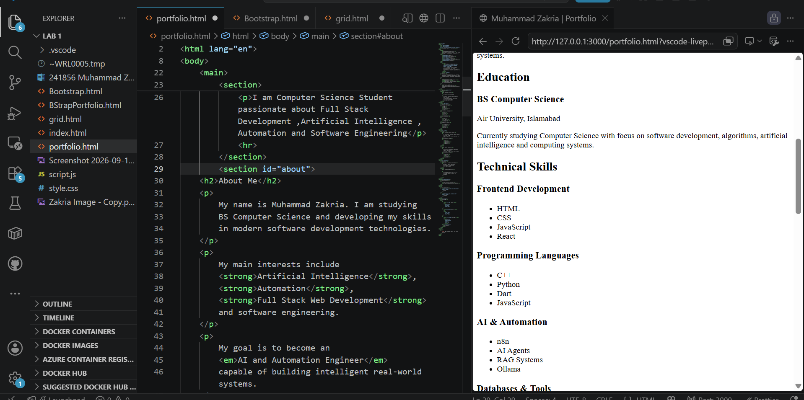

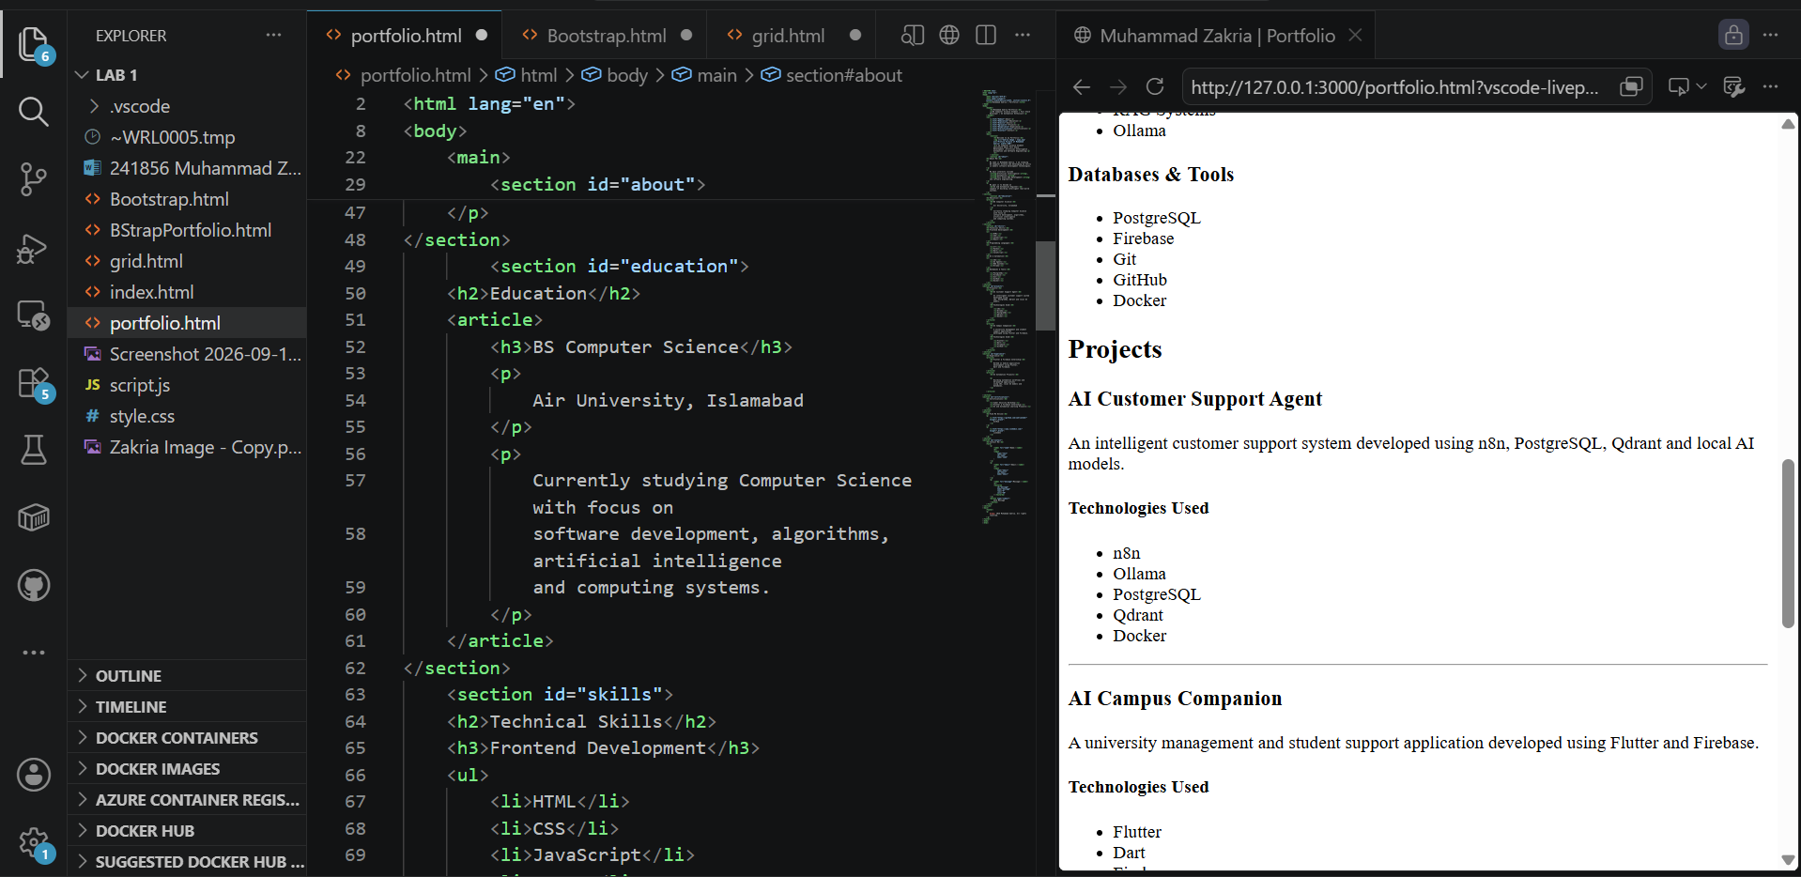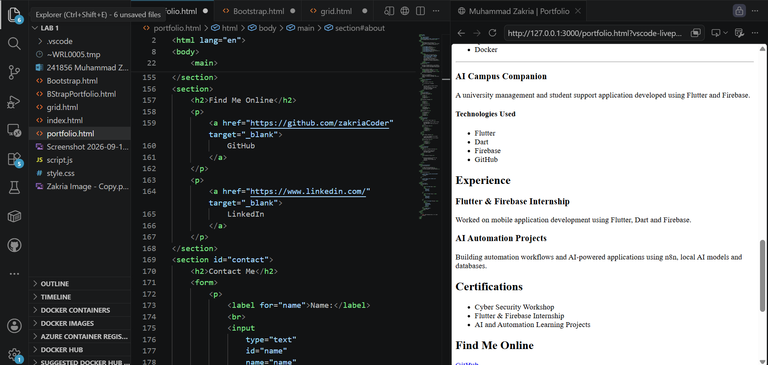

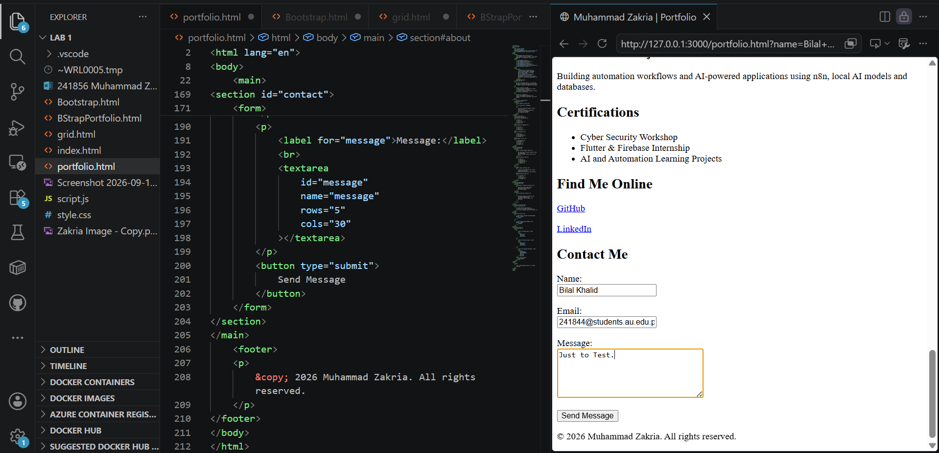

Conclusion:
So basically in this lab I have learned concepts of HTML , Css and Bootstrap . In it I had learned about Inline and block elemens and revised concepts of basic tags .After that learned css for styling and applied on our html web page .
In addition to this after all had done Bootstrap work and applied on our webpage and on out portfolio for responsiveness .

Home Task:
● Use Bootstrap for responsive layout.
● Include a navbar with links.
● Include at least 2 cards with info like skills or projects.
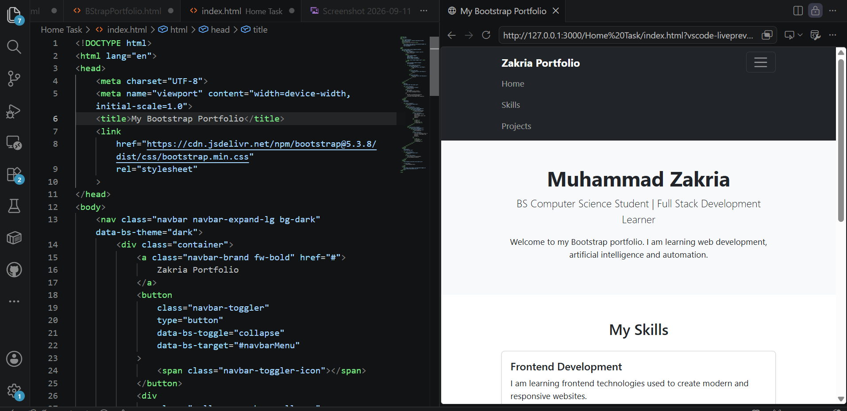
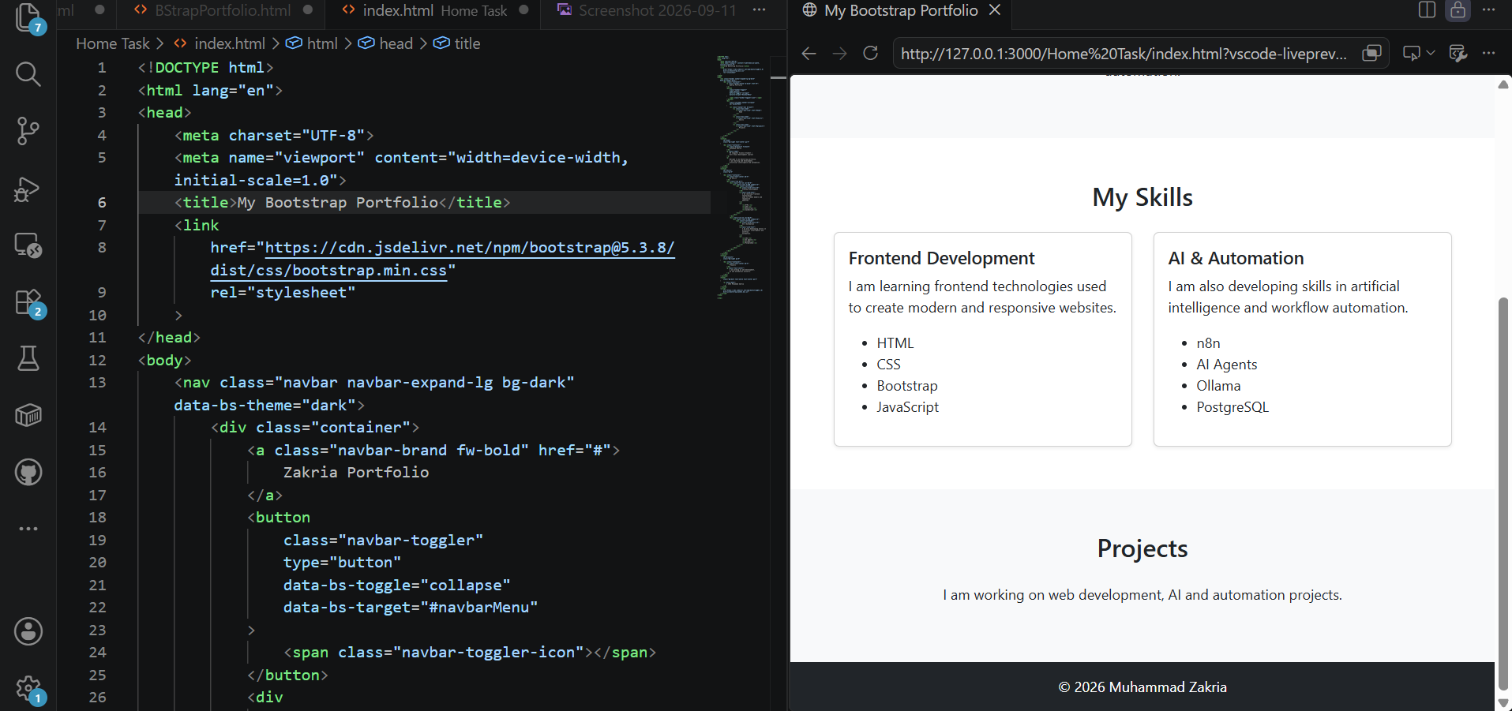

Student Deliverables :
● Working HTML page with Bootstrap components as given below.
